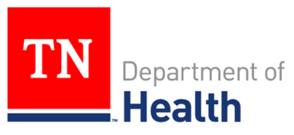
Summer Intern Position 2023
Tennessee Vector-Borne Diseases Program

The Tennessee Department of Health, in collaboration with the CDC Southeastern Center of Excellence in Vector Borne Diseases (SECVBD), is seeking applications for a self-motivated intern to work during the summer of 2023. This position will support a broader, unified effort within the region for tick surveillance, including tick abundance, distribution, identification, and vouchering, and in doing so, it provides an opportunity to gain experience in public health entomology and applied epidemiology while providing support to state and academic partners. Anticipated outcomes of the internship include learning and applying best practices for tick surveillance, including rapid tick identification, tick collection, and tick-borne pathogen testing.

The selected intern will:
- Be exposed to the principles of integrated tick management;
- Gain experience in tick trapping and surveillance;
- Learn about tick biology;
- Travel for field work and for vector surveillance; and
- Conduct disease surveillance or send samples for testing at partnering facilities.

The intern will work approximately 30 hours per week for 13-16 weeks, with a pay rate of $15/hr up to the maximum compensation of $7,200. The deadline to apply is April 1, 2023, with an anticipated start date of May 15, 2023. Must have a valid driver’s license, access to a reliable vehicle, and be willing to drive the vehicle on state business. Travel mileage will be reimbursed.

Basic Qualifications:
- Intern must have graduated with or be actively pursuing a Bachelor’s or Master’s degree in Biological Sciences, Public Health, Entomology, or a related field from an accredited college or university;
- Must be legally authorized to work in the United States;
- Must have a strong interest in vector-borne diseases, infectious diseases, or public health entomology;
- Must be available to complete an online tick training module and attend a three-day, hybrid (virtual/in-person) training on tick surveillance, control, and tick-borne diseases at the onset of the internship (anticipated: June 2023).

Preferred Qualifications:
- Previous experience surveilling for ticks or other vectors;
- Demonstrated time management skills and attention to detail;
- Excellent analytical and problem-solving skills;
- Strong written and verbal communication skills;
- Availability from early May through September (dates may be flexible);
- Ability to work independently and as a team member.

To apply, please submit resume/CV to Dr. Abelardo Moncayo at Abelardo.Moncayo@tn.gov.

